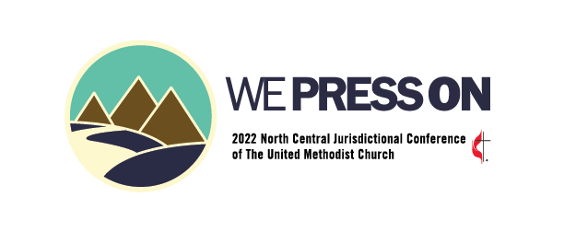

Episcopal Nominee Information
2022 North Central Jurisdictional Conference

Name: Conference:

Street/PO Box Address:

City/State/Zip:

Telephone: Fax: Email:

Current Appointment:

Family:

Background and Experience:

Formal Education (please also include significant Continuing Education):

Ordination Dates and Conference of Which You Were a Member:

Previous Work Experiences and Pastoral Appointments:

Connectional and Ecumenical Church Experiences:
- Current:

- Previous:

Community Service Activity:
- Current:

- Previous:

Publications, Awards, Honors:

Special Interests and/or Hobbies:

Faith and Leadership

Describe Your Understanding of the Nature and Mission of the Church:

Share Your Vision for The United Methodist Church:

Describe Your Concept and Style of Leadership:

Describe Your Gifts and Graces:

Describe How You Have Experienced the Call to the Episcopacy and How God Has Prepared You for the Episcopacy:

Episcopal Candidate Forum:
The North Central Jurisdictional Committee on Episcopacy (NCJCOE) is sponsoring a forum for those persons who choose to offer themselves as episcopal candidates. This forum will consist of a fifteen-minute interview with each episcopal candidate who elects to participate. Candidates who declare their desire to participate in this video forum must notify the NCJ Secretary by August 1. The moderated interviews will be recorded on video during August. All interviews will then be posted on the same date to the North Central Jurisdictional (NCJ) website on or around September 1, 2022. Do you wish to participate in this forum? _____ Yes _____ No

Please submit this Form, Episcopal Election Covenant Form, and a Digital Picture at any time and No Later than September 1, 2022 to be included in the Advance Journal:
Rev. Paul R. White, Secretary
2016 NCJ Conference
3815 Ashwood Street NW
Canton, OH 44708-1603
paulw2800@gmail.com

